# **Creating Event Hub**

This demo is about creating event hub service in azure portal. To create the service, go to **+** **Create a resource -> Internet of Things -> Event Hubs**. Then give it a name, choose a required pricing tier, a resource group and click on create.

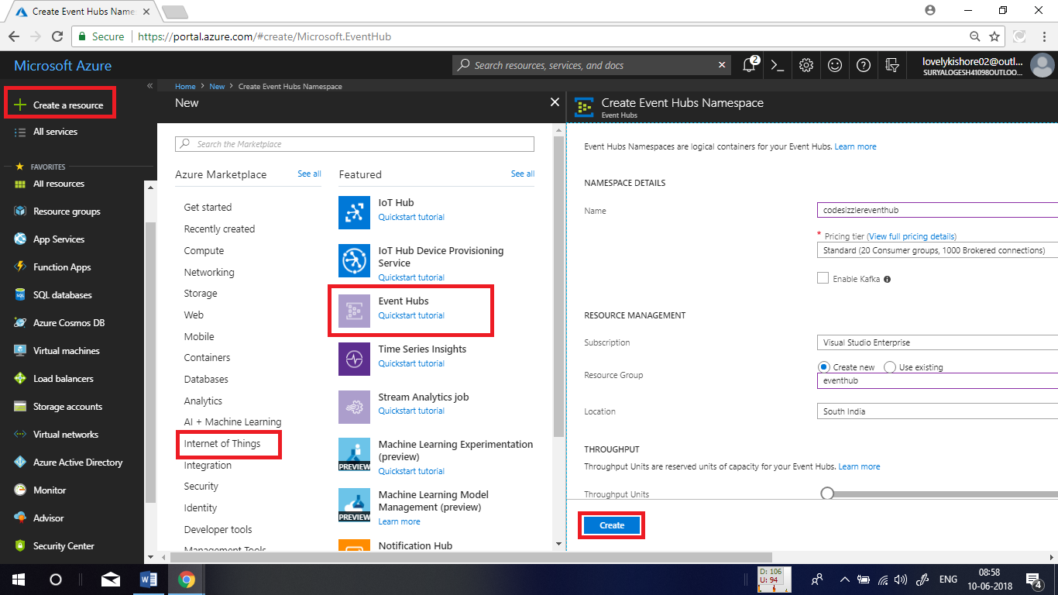

Once the event hub gets created, in its overview page, click on **+ Event Hub** to create event hub.

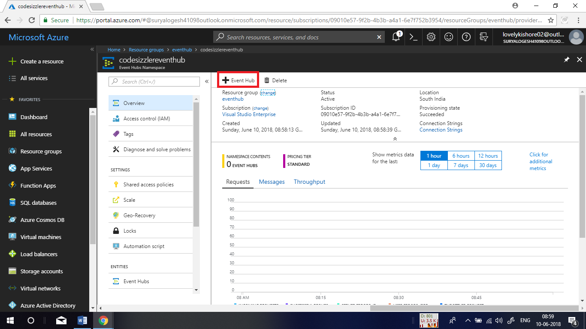

Give a name to the hub and click on **Create**.

